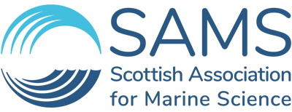
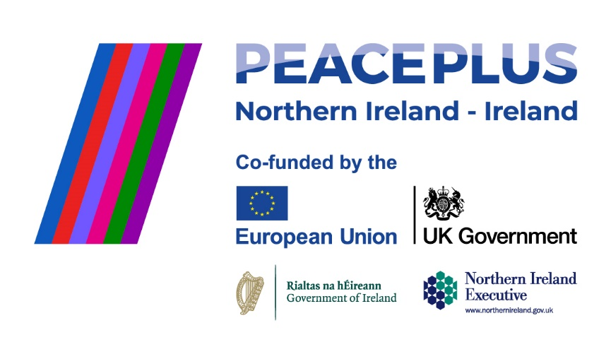

PDRA in Marine Mammal Ecology
Job Description

1. Job Details

Job Title: | PDRA in Marine Mammal Ecology | Department: | Science
Line Manager: | PI/Senior Lecturer and Bioacoustician | Grade: | 5: £31,396 - £34,980  6: £37,099 - £41,732
Full Time/Part Time: | Full Time – 37hrs per week | Duration of Appointment: | Approximately 3 years.  Funding available and duration will depend on the Grade appointed.

2. Job Purpose
- This project is supported by PEACEPLUS, a programme managed by the Special EU Programmes Body (SEUPB).
- Analyse passive acoustic and visual marine mammal and seabird data, develop and test new bioacoustics analysis tools and statistical frameworks, including species distribution modelling.
- Conduct fieldwork, including equipment setup and maintenance, for visual and acoustic marine mammal surveys as required by SAMS Research and Enterprise (e.g., towed array surveys, static and drifting passive acoustics).
- Help secure and deliver commercial contracts, including tender preparation, data processing and analysis, quality assurance, and report writing.
- Provide marine environmental consultancy as part of the SAMS Enterprise team, with a focus on marine mammals, within commercial sectors such as marine fisheries, offshore renewables and aquaculture.
- Involvement in marketing and conferences, and assistance in developing new research/business opportunities within SAMS Research and Enterprise.

3. Main Responsibilities
This position is advertised across two grades. Where a candidate is appointed at the higher grade, the duties and responsibilities will be adjusted on appointment to reflect this.
Main Responsibilities | Approx. % of time
Research: | 68
- Prepare equipment for and undertake fieldwork. Responsibilities here include, but are not limited to, preparing passive acoustic moorings, drifting and towed hydrophone arrays. Fieldwork activities will include deployment and recovery of acoustic moorings, conducting visual and acoustic surveys using towed or drifting arrays, as well as marine mammal photo-ID surveys.
- Support SAMS Marine Mammals Research Team with equipment maintenance, data storage and long-term data curation.
- Use programming (e.g., R, Python, MATLAB), GIS skills and statistical modelling proficiency (e.g., habitat and species distribution modelling and/or population impact modelling) for complex data analyses in support of multi-disciplinary research projects.
- Model species distribution and habitat preferences using passive acoustic and/or visual data to support Marine Protected Area (MPA) monitoring and species conservation.
- Plan and write scientific reports, papers and policy briefs.

Enterprise/Consultancy: | 32
- Apply understanding of impacts on marine mammals, for example from fisheries, aquaculture and underwater noise (e.g., from shipping or the marine energy sector) in the context of Environmental Impact Assessments (EIA) and Habitat Regulations Assessment (HRA) processes.
- Demonstrate and further develop knowledge of the ongoing national and international regulatory and technical developments with regards to PAM, MPAs, underwater noise and fisheries management.
- Support SAMS Marine Mammals Research Team in the tendering process for commercial projects, and deliver advice and research outputs to developers, consultancies and government agencies relating to the various life stages of offshore developments.
- Comply with quality management in the SAMS delivery team to ensure compliance with ISO9001 standard.
Be pro-active in the application of SAMS Health & Safety Procedures | Ongoing

Key Experience and Skills
Qualification and knowledge base:
- PhD with focus on marine mammals, bioacoustics and/or species distribution modelling (essential).
- Ability to analyse complex temporal and spatial, visual/acoustic datasets (essential).
- Evidence of scientific publications and experience sharing knowledge in reports, workshops and at conferences (essential).
- Technical knowledge and expertise in assessing impacts to marine megafauna from industrial sectors such as marine energy, fisheries or aquaculture (essential).
- Technical knowledge and demonstrated practical experience undertaking EIA/HRA impact assessments (desirable).

Technical delivery:
- Contribute to delivery of research and consultancy work as part of the SAMS Marine Mammal Research and Enterprise Team.
- Technically deliver consultancy and research projects within area of expertise.
- Remain current with regulatory requirements regarding species protection, industry needs, and academic progress to develop and deliver high-quality projects (essential).
- Write high-quality scientific papers and reports for research projects and commercial customers (essential).
- Expertise in acoustic data analysis for marine mammals (e.g., PAMGuard, C-POD/F-POD.exe) and underwater sound (e.g., PAMGuide, MATLAB, MANTA) (essential).
- Expertise using standard programming languages (e.g., R, Python, MATLAB) and GIS software (e.g., QGIS) (essential).
- Statistical analysis experience for various data types and long-term data sets (essential).
- Experience with species distribution/habitat and population impact modelling (e.g. GAMs, BRTs, iPCoD, DEPONS etc.; desirable).
- Expertise in acoustic data analysis using other acoustic analysis software (e.g., Raven, AviSoft) (desirable).
- Experience with analysis of photo-ID data (desirable).
- Experience with data quality control and data validation processes (desirable).

Field work:
- Experience in offshore vessel-based survey organisation, execution and management (particularly relating to deployment and retrieval of PAM equipment; essential).
- Experience operating and maintaining passive acoustic monitoring equipment (e.g., Soundtraps, RTSYS EA-SDA14 & Sylence, C-/F-PODs; essential).
- Experience with mooring design and acoustic mooring preparation, including use of acoustic release mechanisms (desirable).
- ENG1 and PST certificates (or equivalent/higher; desirable).

Planning and Organising:
- Good knowledge, experience and practice of project management to successfully deliver technically complex commercial contracts and projects (essential).
- The ability to progress and deliver multiple research and commercial projects concurrently (essential).
- Demonstrated previous experience of successful project delivery and the ability to apply that experience in research and commercial projects (essential).
- Good understanding and application of project management principles, including the different components required to ensure successful delivery (e.g., some knowledge of costing/estimating, finance and time management; desirable).

Decision-Making:
- Manage own workload to quality and timescales of projects (essential).
- Collaboratively develop and deliver scientifically robust analyses using appropriate methodologies, considering latest legislative requirements and recent scientific progress (essential).
- Be proactive in terms of prioritisation of projects and resources, given that the role requires concurrent progress and delivery of multiple projects (essential).
- Respond effectively to problems during project lifetimes (e.g., weather delays, resource unavailability, external supplier issues; essential).

Key Contacts/Relationships:
- SAMS staff and external project partners for a successful delivery of the project.
- Develop or maintain professional connections with representatives from UK/Scottish Government, UK Statutory Nature Conservation Bodies, industry representatives, and other stakeholders such as Non-Governmental Organisations (NGOs), community groups, etc. (essential).
- Work closely with SAMS Enterprise to deliver work to the customer’s needs and satisfaction, identify and generate new leads and opportunities resulting in new project contracts (essential).
See project details here: http://www.seupb.eu/PEACEPLUS
What can SAMS offer you?
Please right click and select ‘open in new tab’
Our Values and culture
We strive to be a world-class marine science enterprise that underpins regional, national, and international policy, and societal action to secure healthy and sustainable oceans.
As a workforce, we have a strong family and team culture, helping each other to achieve our goals.
Remuneration
We offer a competitive salary and pension as well as employee benefits package. We also have a number of supportive policies to assist absence, family, and other leave types.
Career Goals
SAMS provides a supportive learning and career growth environment for those looking for that next step in their career or upskill in the workplace. This may be through opportunities to develop techniques, learn more about the science objectives for the group, gain some tutorial opportunities, as well as attend meetings and CPD events.

We’ll provide you with a good start as you join SAMS
SAMS provides an excellent induction which is a great introduction to the organisation, the facilities, your department and team, and provides that support that you need over the early months joining a new organisation. We will also provide you with office space, computing equipment and ensure this is ready for you on your first day of work.
Employee Benefits
In addition to a general remuneration package which includes a generous salary, pension, and sickness absence policy, we offer a number of employee benefits to our staff, some of which are listed below:

- Flexible & Hybrid working arrangements (up to 2 days working from home) – will depend on role dynamic.
- Purchase of additional annual leave – up to 20 days per annum
- Access to shopping discounts as well as local shop and leisure discounted memberships
- Cycle to work scheme
- Purchase of technology
- Payroll Giving
- Salary Sacrifice – pensions
- Access to wellbeing portals which provide support for mental health, nutrition and fitness and GP referral scheme
- Occupational health support
- Welfare support on site
- Sabbatical scheme
- A number of training and development courses to assist you with your career development – leadership, coaching and mentoring.
- Free car parking
- Electric car charge points on-site

As an Academic Partner of the University of the Highlands & Islands (UHI), SAMS is designated as an educational establishment and subject to the provisions of the Protection of Children (Scotland) Act. Certain roles may be subject to a satisfactory check by Disclosure (Scotland) as a condition of their appointment.
Applications must include CV and Cover Letter and should be sent electronically to recruitment@sams.ac.uk quoting Job Ref. ‘D10/25.DR’ in the subject line.
The closing date for applications is 2nd November 2025.
Interviews to be held shortly thereafter.
Please note, we prefer to contact referees prior to interview.
Guidance for Applicants
This position unfortunately does not meet the minimum requirements for sponsorship to work in the UK. You must therefore have the rights in place to work in the UK already.
Your application – what are we looking for?
We are looking for a full CV – please remember to document all your relevant work experience, listed with the most recent first. You should also include your educational achievements with your most recent qualification first. You should include skills and competencies gained from previous employment or education. This should be specific to the job description. Also, please include details of two referees, one referee at least from your current role, who we may contact if invited for interview.

We enjoy reading cover letters and these are an important part of the application. In the letter, connect your past accomplishments with the requirements listed in the job description. Focus on your most relevant experience, qualifications, and skills. Where possible, quantify your accomplishments with facts and data.
Useful links
- How to write a flawless cover letter (please right click and select open in new tab)
- How to write a CV (please right click and select open in new tab)

