UHI STEM Coordinator (Outreach) - Job Description

1. Job Details

Job Title: | UHI STEM Coordinator (Outreach) | Job Family: | Management, Specialist & Administration
Line Manager: | Head of Communications | Grade Range: | Grade 5, Sp24
Full Time/Part Time: | Part Time, 18.5hrs per week (0.5 FTE, flexible, annualised) | Duration of Appointment: | 3 years

2. Job Purpose

The UHI STEM Coordinator (Outreach) post at SAMS is one of ten positions across the University of the Highlands and Islands (UHI) region and part of a 3-year UHI STEM Development Outreach Programme. The postholder will contribute to local STEM partnership meetings, ensuring local (if possible, data-informed) STEM plans are developed, delivered and reported annually.

The postholder will coordinate and deliver STEM engagement activities for the Scottish Association for Marine Science (SAMS), a partner of UHI, with a focus on early year and first stage learners (EYFS) and primary schools. This role contributes to a coordinated, collaborative UHI regional STEM approach.

The postholder will prepare grant proposals to allow for the further development and expansion of STEM activities for SAMS and UHI and write reports. A particular content focus on ocean literacy and the blue economy are desirable. The role contributes to the SAMS strategy for education for a better future, ‘to encourage and support the young to value, study and protect the marine environment.’

3. Main Responsibilities
Role Description | Approx. %  of time
Contribute to local STEM partnership for Argyll and Bute  - Contribute to, facilitate or coordinate local STEM partnership meetings  - Agree annual STEM engagement plan  - Develop funded projects and events that raise the profile of UHI STEM in Argyll  - Maximise resource utilisation  - Evaluate, record and report on all STEM related activities at SAMS  - Contribute to UHI STEM Strategic Plan with STEM Development Manager | 40
Deliver outreach engagement and events  - Design and deliver STEM engagement projects and events within agreed budgets on ocean related topics  - Coordinate and deliver UHI STEM engagement activities locally, including the early years and primary school engagement model ‘Lend a Lab’ that provides in class / in school support to teachers and probationers in STEM subjects  - Maintain records of school STEM involvement and conduct evaluations on effectiveness of STEM programme to ensure funder requirements are met  - Provide support to other key regional STEM engagement activities when required  - Support the development of a community of practitioners with other UHI STEM coordinators (outreach) | 50
General responsibilities  - Identify, manage and report on risks associated with the role  - Participate in annual performance and development reviews  - Attend training courses that your line manager deems necessary  - Be pro-active in the application of SAMS and UHI Health and Safety procedures  - Be an active member of the SAMS Communications team and regularly attend team meetings | 10
Be pro-active in the application of SAMS Health and Safety Procedures and Quality Management System | Ongoing

4. Planning and Organising
The postholder must have good logistical skills to plan and organise meetings, events and workshops that are delivered on time and in budget. They need to be able to plan within a broader strategy, taking a big picture approach.

5. Problem-Solving
Problem-solving is a key skill the postholder is expected to not just display but teach. They need to be able to crisis manage planned events when conditions such as poor weather, transport links or sickness of key personal require fast changes to be made to plan without compromising the health and safety at any time. They may also need to be able to find excellent alternative modes of delivering STEM should unforeseen circumstances (e.g. Covid) require this.

6. Decision-Making
The postholder will work with their line manager and the UHI partnership to decide on the schools and projects to work with and the resources to leverage or develop. They will also decide on grant opportunities to pursue.

7. Key Contacts/Relationships
The postholder will be an active member of the SAMS Communications team as well as the UHI STEM Coordinators, working closely with the UHI Head of STEM Development and the network of UHI STEM Coordinators. They will develop and deepen relationships SAMS has with other STEM providers and agencies in Argyll. They will also work with individual scientists in developing new STEM activities and to ensure all STEM activities are informed by the latest research.

Critically, they will be an active part of the local STEM partnership, that is currently not fully developed. The UHI region is one of thirteen STEM partnership regions which capture the collaborative approach to the delivery of the Scottish Government’s STEM strategy. Due to the complexity (large geographical size and rural nature) of the Highlands and Islands, we have developed a 3-tier model.

- Regional Highlands and Islands STEM Partnership (HISP)
- UHI Satellite STEM Leads (SSL)
- Local STEM Partnerships
The Highland and Islands STEM Partnership (HISP) is a strategic collaborative that advises on, supports, and promotes Science Technology Engineering Math's education opportunities from our partners across the University of the Highlands and Islands region.

The HISP champions excellent STEM learning, teaching, and opportunities, from early years, through primary and secondary schools, to Further and Higher Education and beyond. The HISP supports planning to ensure that all learners across the Highlands and Islands are given the opportunity to develop STEM pathways, with a clear focus on equalities and the challenges of rural and remote learning.

HISP members identified that a key development is the interpretation and use of STEM data on pupil intensions, school enrolments and demographics trends in STEM subject entrants at schools, colleges, and university to support labour market insights and forecast future trends.
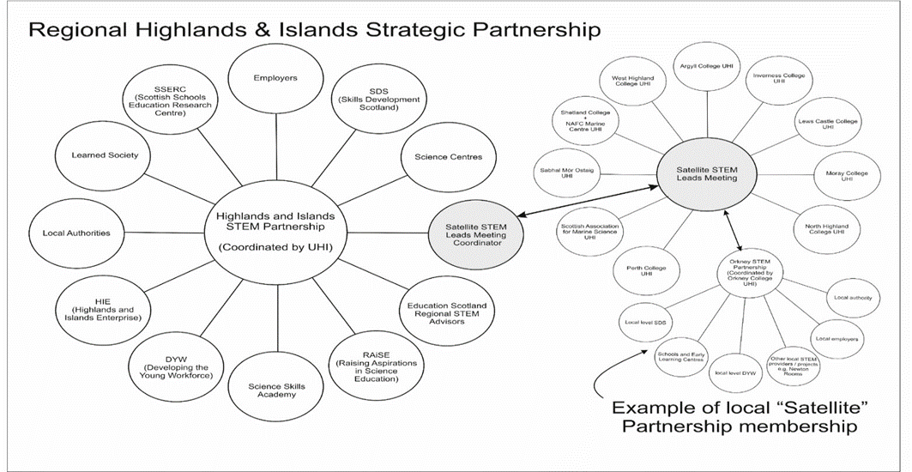

The UHI Satellite STEM Leads (SSL) is an internal UHI group with a membership from across the partnership including executive office teams linked with STEM including school’s recruitment, Faculty of Science, Health & Engineering Subject Network Leads, and the nominated STEM representatives from UHI academic partners.

The SSL group provides a critical link between regional strategy focus and local based satellite STEM partnership groups. The STEM Coordinator (Outreach) will be a critical link between SSL and local STEM Partnerships by in actively leading or by supporting/facilitation of their local STEM partnership groups in whatever form that they take.

3 Local STEM Partnerships have developed at variable rates due to local capacity and have been impacted by the pandemic. Our ambition is to develop/support collaboration at local level with key stakeholders and STEM partners. Facilitating local coordination at a local level enables us to identify local gaps and create plans to address these through the local STEM partnership. These local STEM plans have the potential to leverage additional funding to support STEM initiatives by harnessing links with investment, e.g., local ‘growth deals’ like Moray, Argyll (Rural), and the Islands Deals.

8. Knowledge, Skills and Experience needed for the Job

Essential Knowledge & Skills: | - Educated to degree level or equivalent in STEM or related discipline.
Desirable knowledge and skills: | - Knowledge and understanding of the Highlands and Islands.  - Experience of handling difficult situations in a positive and confident manner and be robust in dealing with negative outcomes.  - Evidence of good prioritisation and time management skills.
Essential Experience: | - Working in STEM engagement or science communication delivery is schools or equivalent context.  - Experience of organising and delivering STEM engagement and community events, meeting agreed targets and timescales.  - Working in partnership with industry and external agencies to promote and develop programmes of activities.  - Leading programmes of activities that deliver agreed targets within timescales and budgets.  - Appropriate level of data protection, security and confidentiality awareness.  - Ability to understand, analyse and summarise information with good IT and social media skills.
Desirable Experience: | - Working in early years or primary school education  - Working within an academic or education organisation.
Essential Knowledge and Skills: | - Knowledge of Scotland’s Curriculum for Excellence and familiarity with STEM curriculum expectations and outcomes.  - Excellent interpersonal skills in dealing with academic colleagues and external stakeholders.  - Ability to work and act on own initiative as well as part of a team to complete tasks and projects.  - Outstanding communication skills both orally and written, appropriate to a range of audiences including children.  - Ability to maintain accurate records and write report.  - Good understanding of marine science and the Argyll marine environment.
Other Skills: | - It’s essential for the job holder to be willing and able to travel with the Highlands and Islands and occasionally further afield, and to have a driving licence so they can use either their own or an institute vehicle to visit schools and attend meetings.  - Desirable would be a knowledge of or interest in the Gaelic language and culture.

9. Dimensions – Scope of role
This is an exciting role involved in the strategically desirable development of a substantially enhanced STEM activity at SAMS and UHI. There is the potential to be centrally involved in the development of an ocean-focused STEM hub for Argyll and Bute.

10. Any other relevant information

The post holder may be required to perform duties other than those given in the job description for the post. The particular duties and responsibilities attached to posts may vary from time to time without changing the general character of the duties or the level of responsibilities entailed. If the normal duties of the post include going to sea (apart from small boats e.g. RHIB's) the applicant must be able to obtain the ENG1 medical certification and complete the STCW 95 Personal Survival Techniques training.

WHAT SAMS CAN OFFER YOU (please right click and select open in new tab)

Our Values and Culture
We strive to be a world-class marine science enterprise that underpins regional, national, and international policy, and societal action to secure healthy and sustainable oceans.
As a workforce, we have a strong family and team culture, helping each other to achieve our goals.
Remuneration
We offer a competitive salary and pension as well as employee benefits package. We also have a number of supportive policies to assist absence, family, and other leave types.
Career Goals
SAMS provides a supportive learning and career growth environment for those looking for that next step in their career or upskill in the workplace. This may be through opportunities to develop techniques, learn more about the science objectives for the group, gain some tutorial opportunities, as well as attend meetings and CPD events.
We’ll provide you with a good start as you join SAMS
SAMS provides an excellent induction which is a great introduction to the organisation, the facilities, your department and team, and provides that support that you need over the early months joining a new organisation. We will also provide you with office space, computing equipment and ensure this is ready for you on your first day of work.
Employee Benefits
In addition to a general remuneration package which includes a generous salary, pension, and sickness absence policy, we offer a number of employee benefits to our staff, some of which are listed below:

- Flexible & Hybrid working arrangements (up to 2 days working from home FTE)
- Purchase of additional annual leave – up to 20 days per annum
- Access to shopping discounts as well as local shop and leisure discounted memberships
- Cycle to work scheme
- Purchase of technology
- Payroll Giving
- Salary Sacrifice – pensions
- Access to wellbeing portals which provide support for mental health, nutrition and fitness and GP referral scheme
- Occupational health support
- Welfare support on site
- Access to free CBT sessions
- Sabbatical scheme
- A number of training and development courses to assist you with your career development – leadership, coaching and mentoring.

SAMS is part of the University of the Highlands & Islands and holds an Athena SWAN Bronze award. SAMS is currently working towards a silver award.
As an Academic Partner of UHI, SAMS is designated as an educational establishment and subject to the provisions of the Protection of Children (Scotland) Act. Certain roles may be subject to a satisfactory check by Disclosure (Scotland) as a condition of their appointment.

Applications must include CV and Cover Letter and should be sent electronically to recruitment@sams.ac.uk quoting Job Ref. ‘D24/22.AM’ in the subject line.

The closing date for applications 27th February 2023

Interviews will be held on 9th March 2023.

Please note, we prefer to contact referees prior to interview

Guidance for Applicants
Candidates must have the rights to work in the UK.

Your application – what are we looking for?
We are looking for a full CV – please remember to document all your relevant work experience, listed with the most recent first. You should also include your educational achievements with you most recent qualification first. You should include skills and competencies gained from previous employment or education. This should be specific to the job description. Also, please include details of two referees, one referee at least from your current role, who we may contact if invited for interview.
We enjoy reading cover letters and these are an important part of the application. In the letter, connect your past accomplishments with the requirements listed in the job description. Focus on your most relevant experience, qualifications, and skills. Where possible, quantify your accomplishments with facts and data.
Useful links
- How to write a flawless cover letter (please right click and select open in new tab)
- How to write a CV (please right click and select open in new tab)

